Indefinite Integral
Hossein Rahimzadeh
www.cafeplanck.com
info@cafeplanck.com

Type1
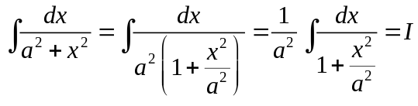
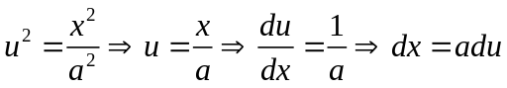
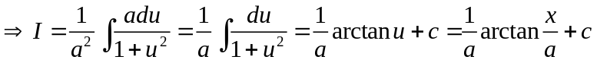

Example
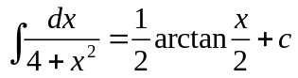
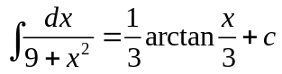

Type2
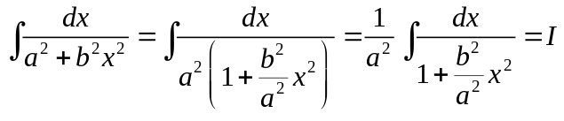
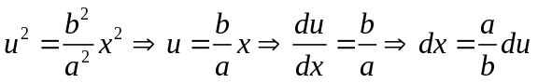
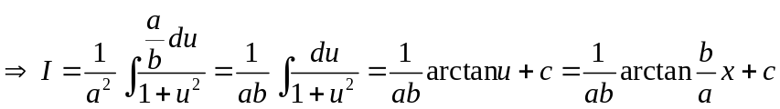

Example
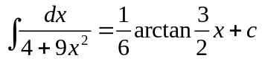
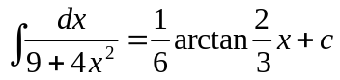

Type3
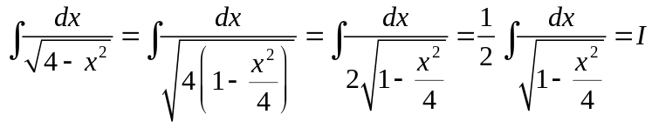
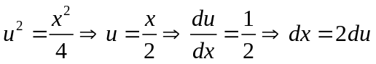
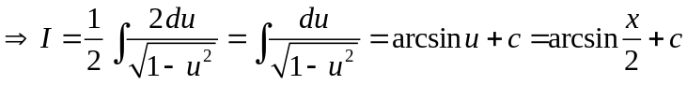

Example
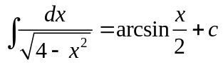
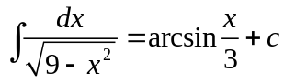

Type4
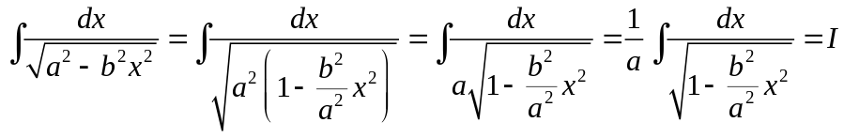
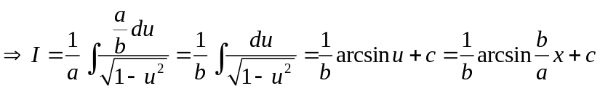

Example
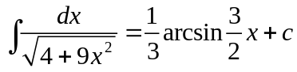
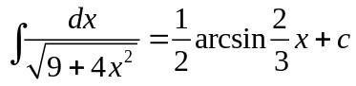

Type5
;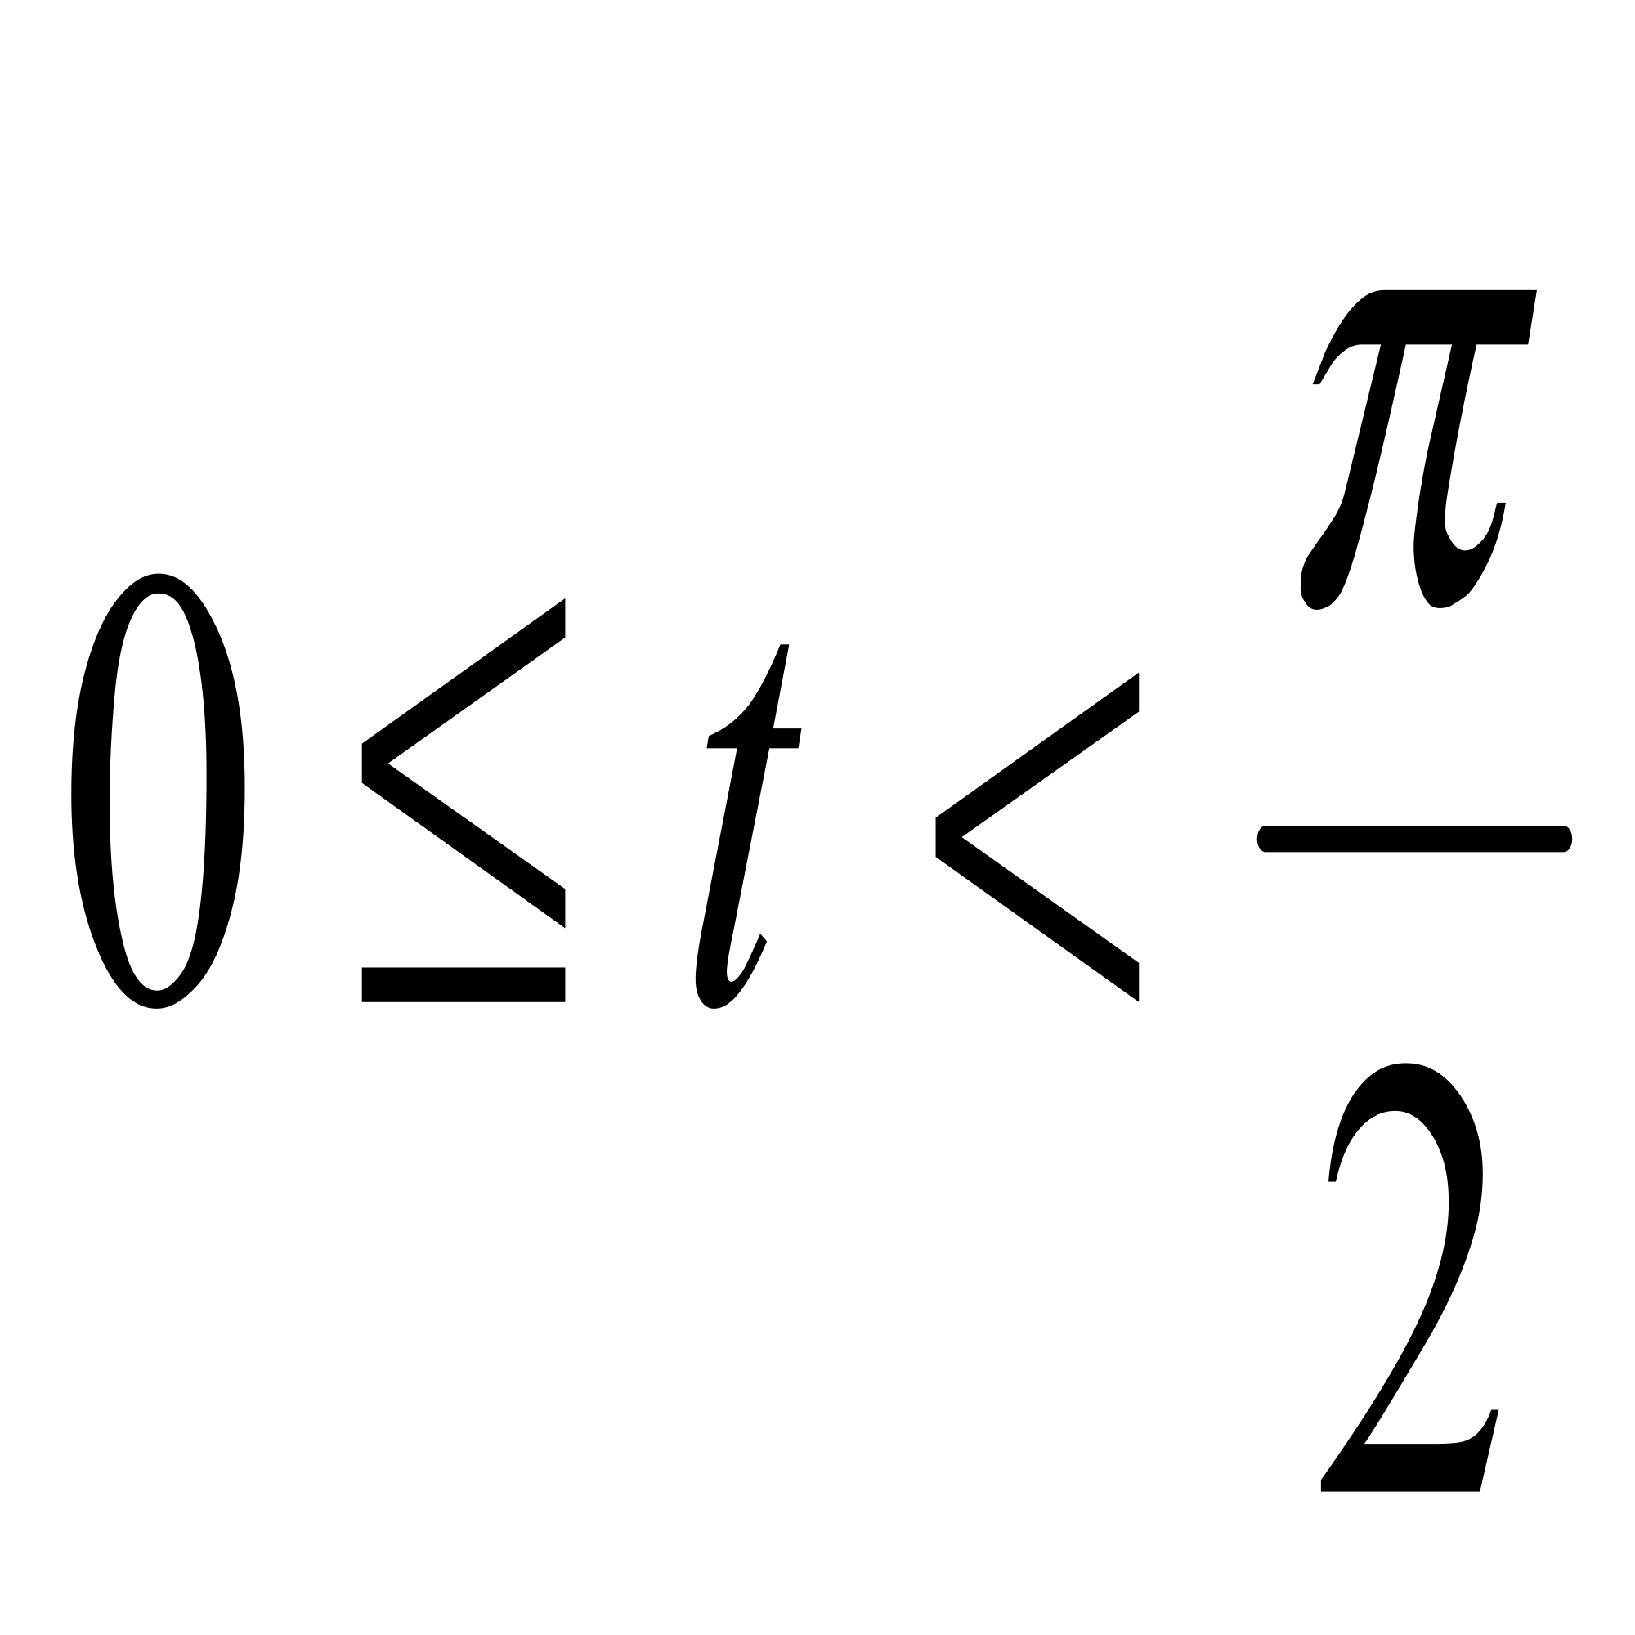
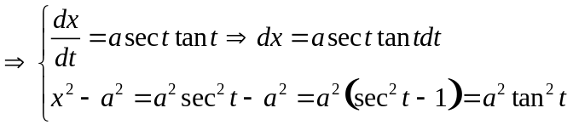

Example
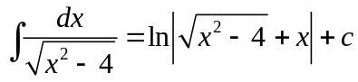

Type6
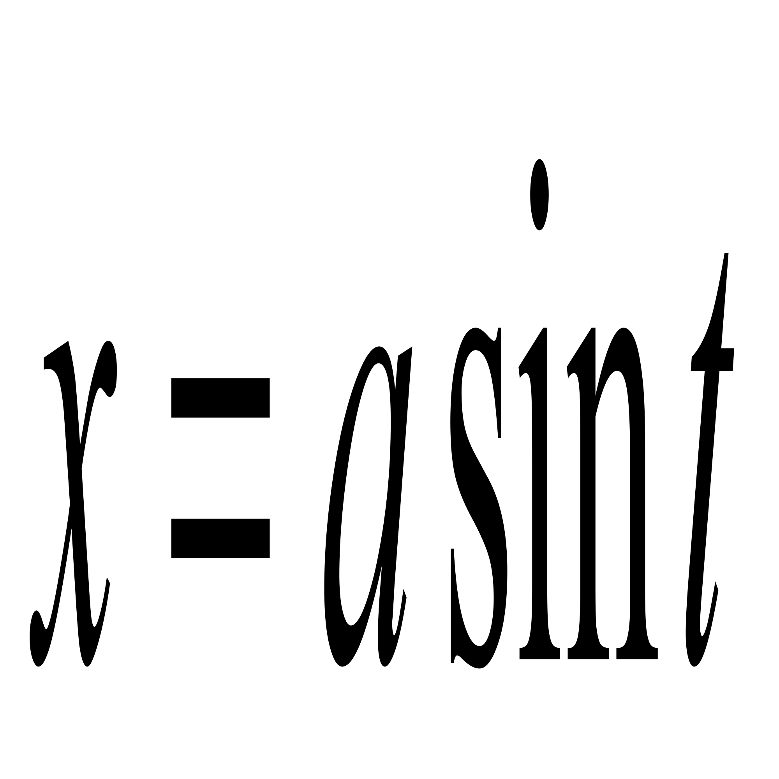;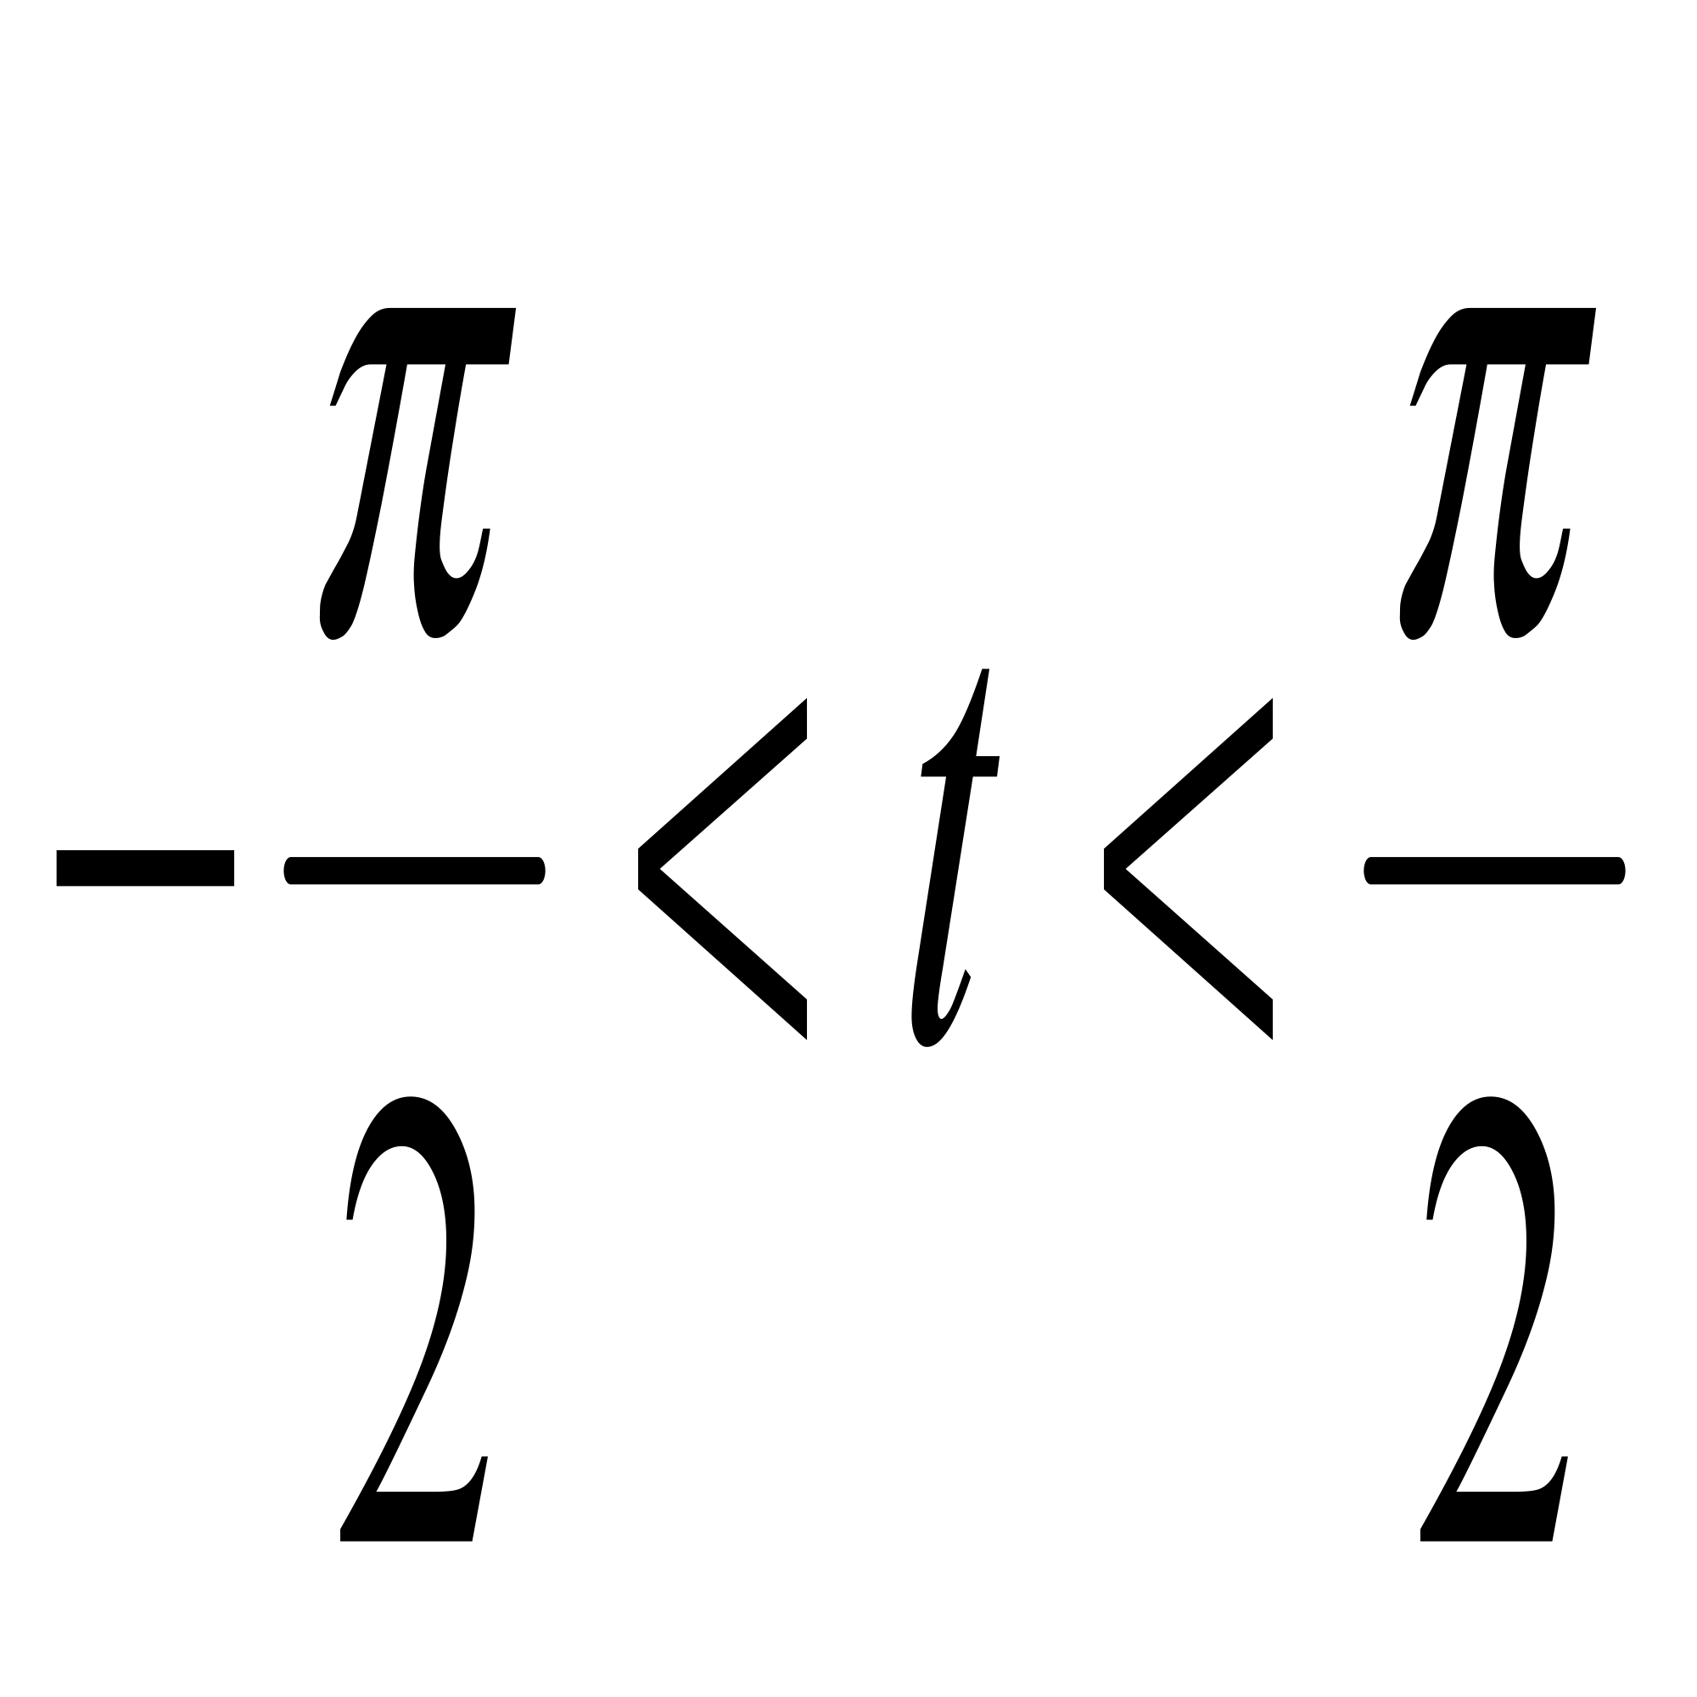
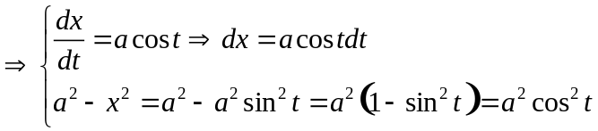
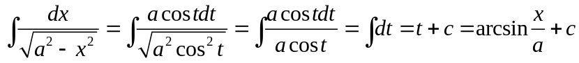

Example

Type7
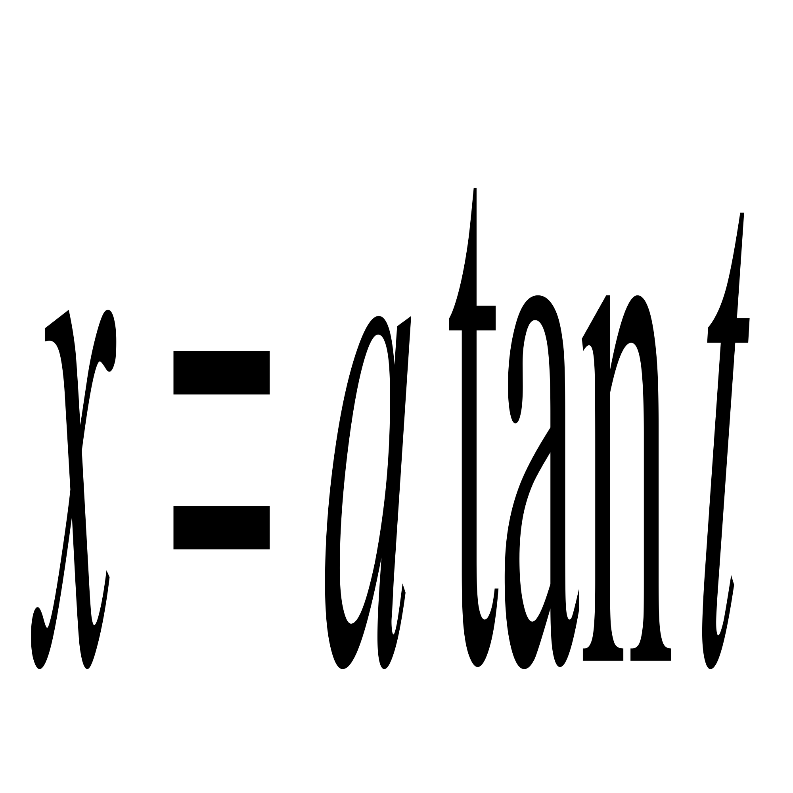;
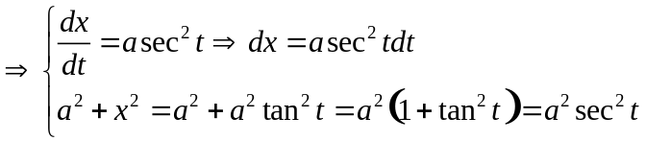
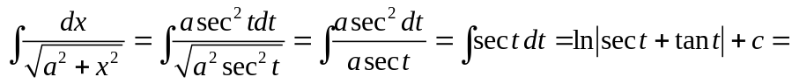

Example
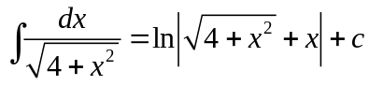
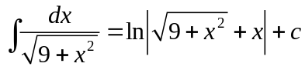

Type8
;
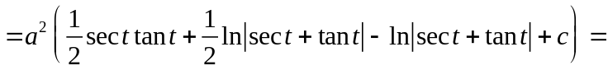
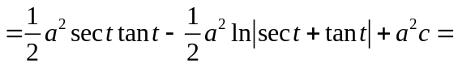
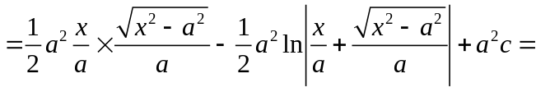
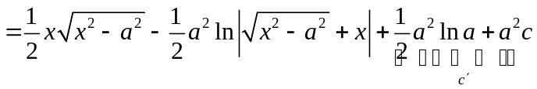
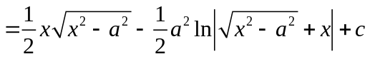

Example
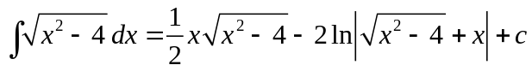

Type9
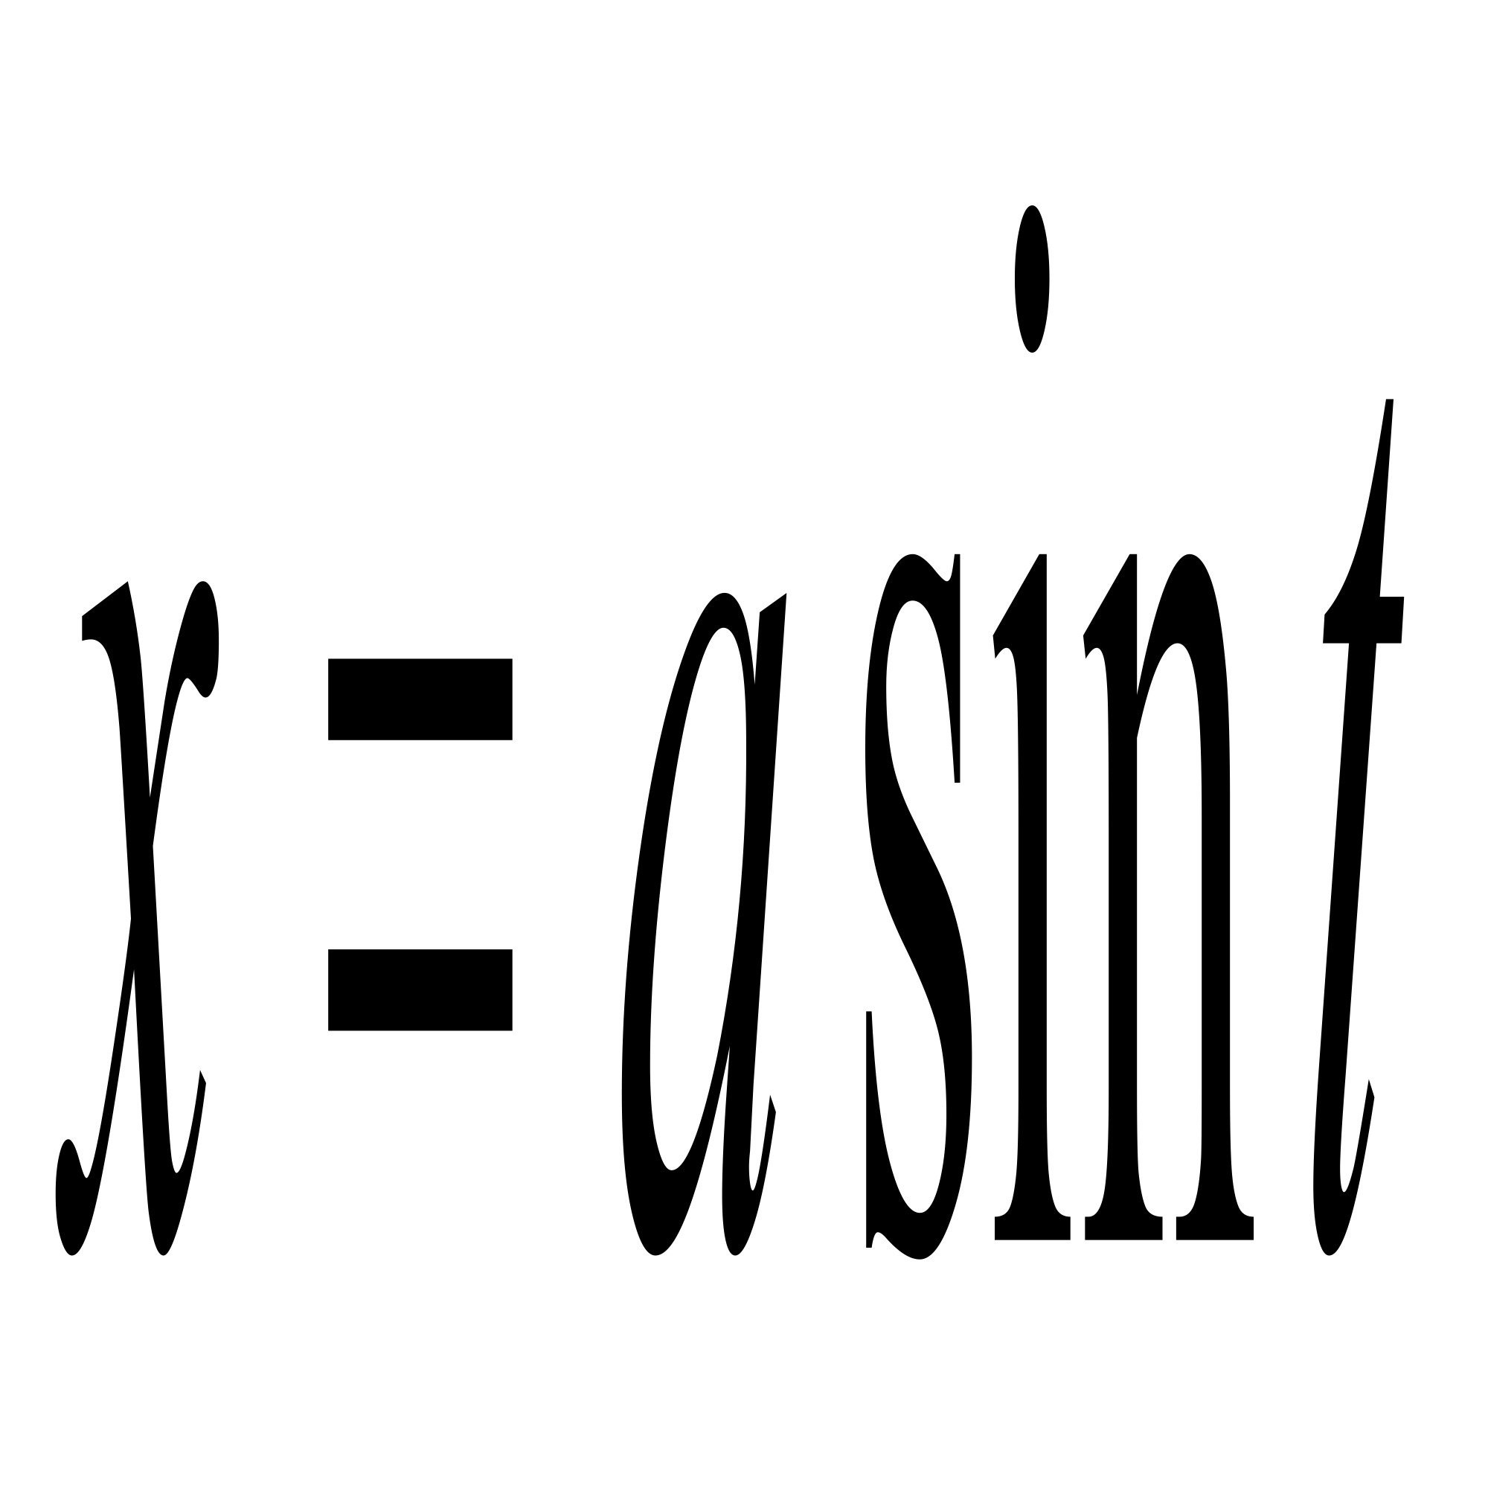;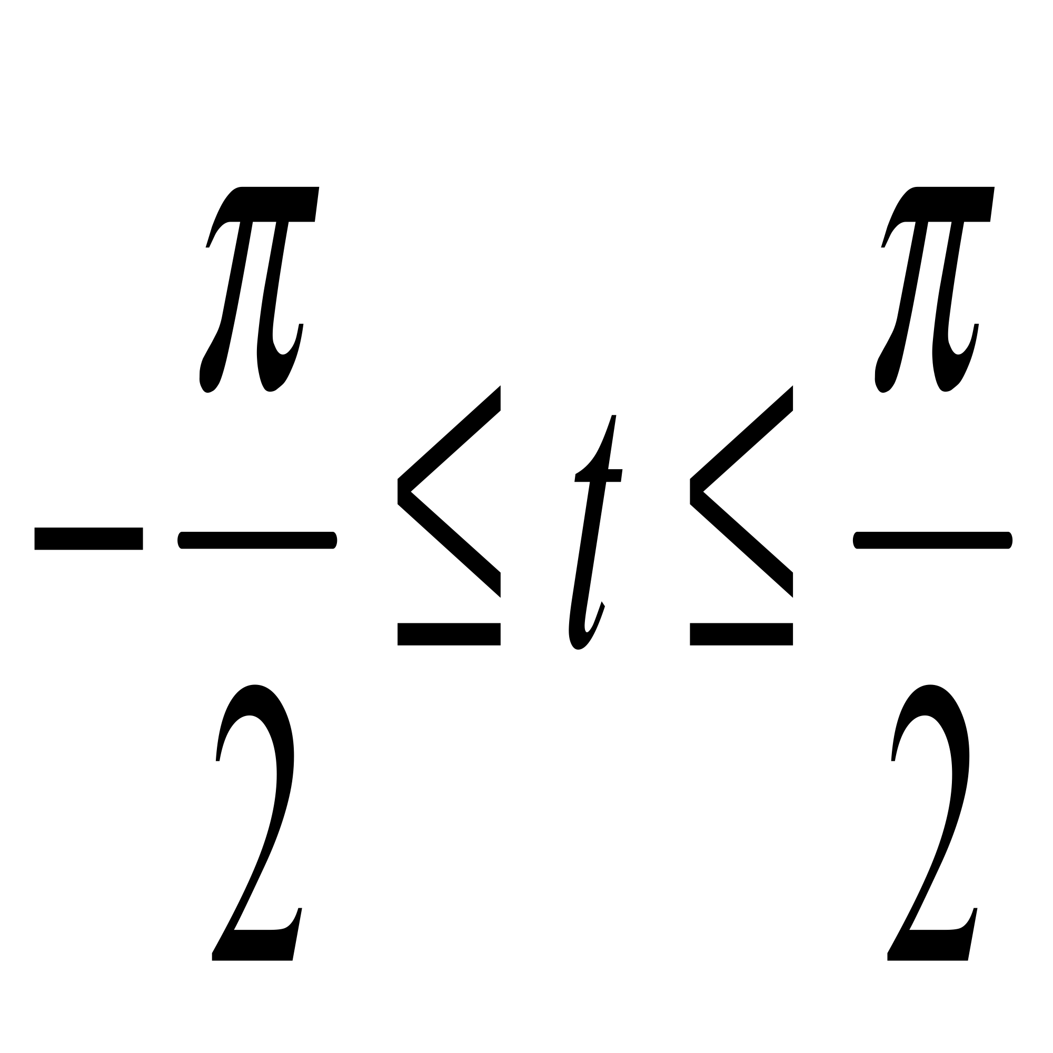
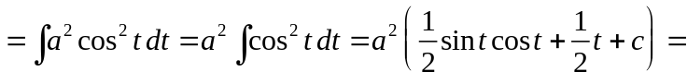
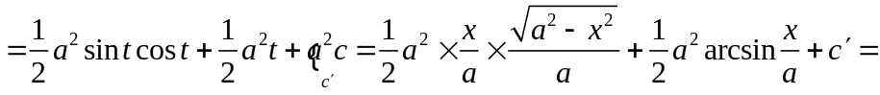
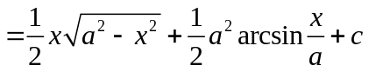

Example
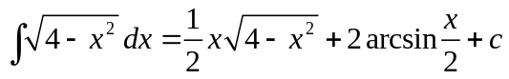

Type10
;
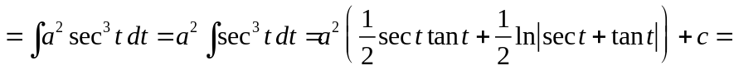
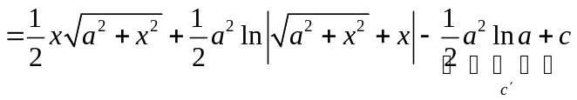
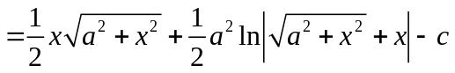

Example
